Insurance Data Transfer Guide

Model User Guide Requirements for the transmission of insurance policy data to support the verification of mandatory auto insurance.

Version 1.2
January 3, 2017

Insurance Industry Committee on
Motor Vehicle Administration

Table of Contents

Section One............................................................................................................................ 1
Introduction to the Model User Guide Requirements for transmitting insurance policy
data..................................................................................................................................... 1

Section Two............................................................................................................................ 2 Data File Transfer Guidelines.............................................................................................. 2 Data Transfer Process......................................................................................................... 2 Submission of Data Files..................................................................................................... 3 State’s System – Receipt of Insurance Data Files.............................................................. 3 State’s System – File Format Validation............................................................................. 3 State’s System – File Process ............................................................................................. 3 State Jurisdiction – Insurance Verification Process........................................................... 4
Data File Format ................................................................................................................. 4
Detail Record...................................................................................................................4
Trailer Record..................................................................................................................5

Insurance Industry Committee on Motor Vehicle Administration

Section One

Introduction to the Model User Guide Requirements for transmitting insurance policy data
The IICMVA supports the use of the IICMVA Online Insurance Verification Model using web services technology and does not consider a data transfer process (often referred to as a Book of Business data transfer) to be part of the Online Insurance Verification Model.

However, the IICMVA also recognizes that a jurisdiction may want a one-time data file transfer to establish a current insurance company of record to associate with their registered vehicles. This process is intended for the express purpose of facilitating a jurisdiction’s ability to send an online insurance verification query.

If a jurisdiction determines there is a need for insurance companies to provide additional insurance information, the IICMVA has established this guide which defines a standardized methodology and data file format for the consistent submission, implementation and use of the provided supplemental data.

Insurance Industry Committee on Motor Vehicle Administration

1

Section Two

Data File Transfer Guidelines

Data Transfer Process
This section provides guidance for supporting the online insurance verification model. If a state implements the following process, IICMVA recommends a one-time data transfer.
This process eliminates the need for the industry to resolve unmatched vehicle records.
Prior to electing to implement this process, full consideration of the following inherent limitations of “point-in-time” data files should be evaluated:

- Data elements often do not match
Collection of data, such as policy numbers, VINs, and customer information by separate entities may result in mismatched data. Consequently, data transfer files may not match all registered
vehicles.

- Participation by commercial insurers may not be possible
The need to collect and process vehicle data elements varies among commercial insurers. Since some commercial insurers do not maintain specific vehicle data, they would not be able to provide this information and a secondary method may need to be implemented.

- Data may be restricted to jurisdictional boundaries
Auto liability policies are commonly written in the state the vehicle is garaged. The state where the policy is written could differ from the state in which the vehicle is registered. Consequently, insurance companies may not be able to identify the correct state of registration for each insured vehicle. This may result in submission of data files that do not contain all vehicles that are registered in the policy state and conversely, may contain vehicles that are not registered in the policy state.

- Data provided is only valid at the time the file is created
Policy changes and transfers between companies occur frequently and will result in some portion of the data provided to become obsolete after a data file is created. As a result, the current insurer of record of some registered vehicles may be misidentified.

The following process flow diagram has been provided to illustrate the electronic data transfer process:

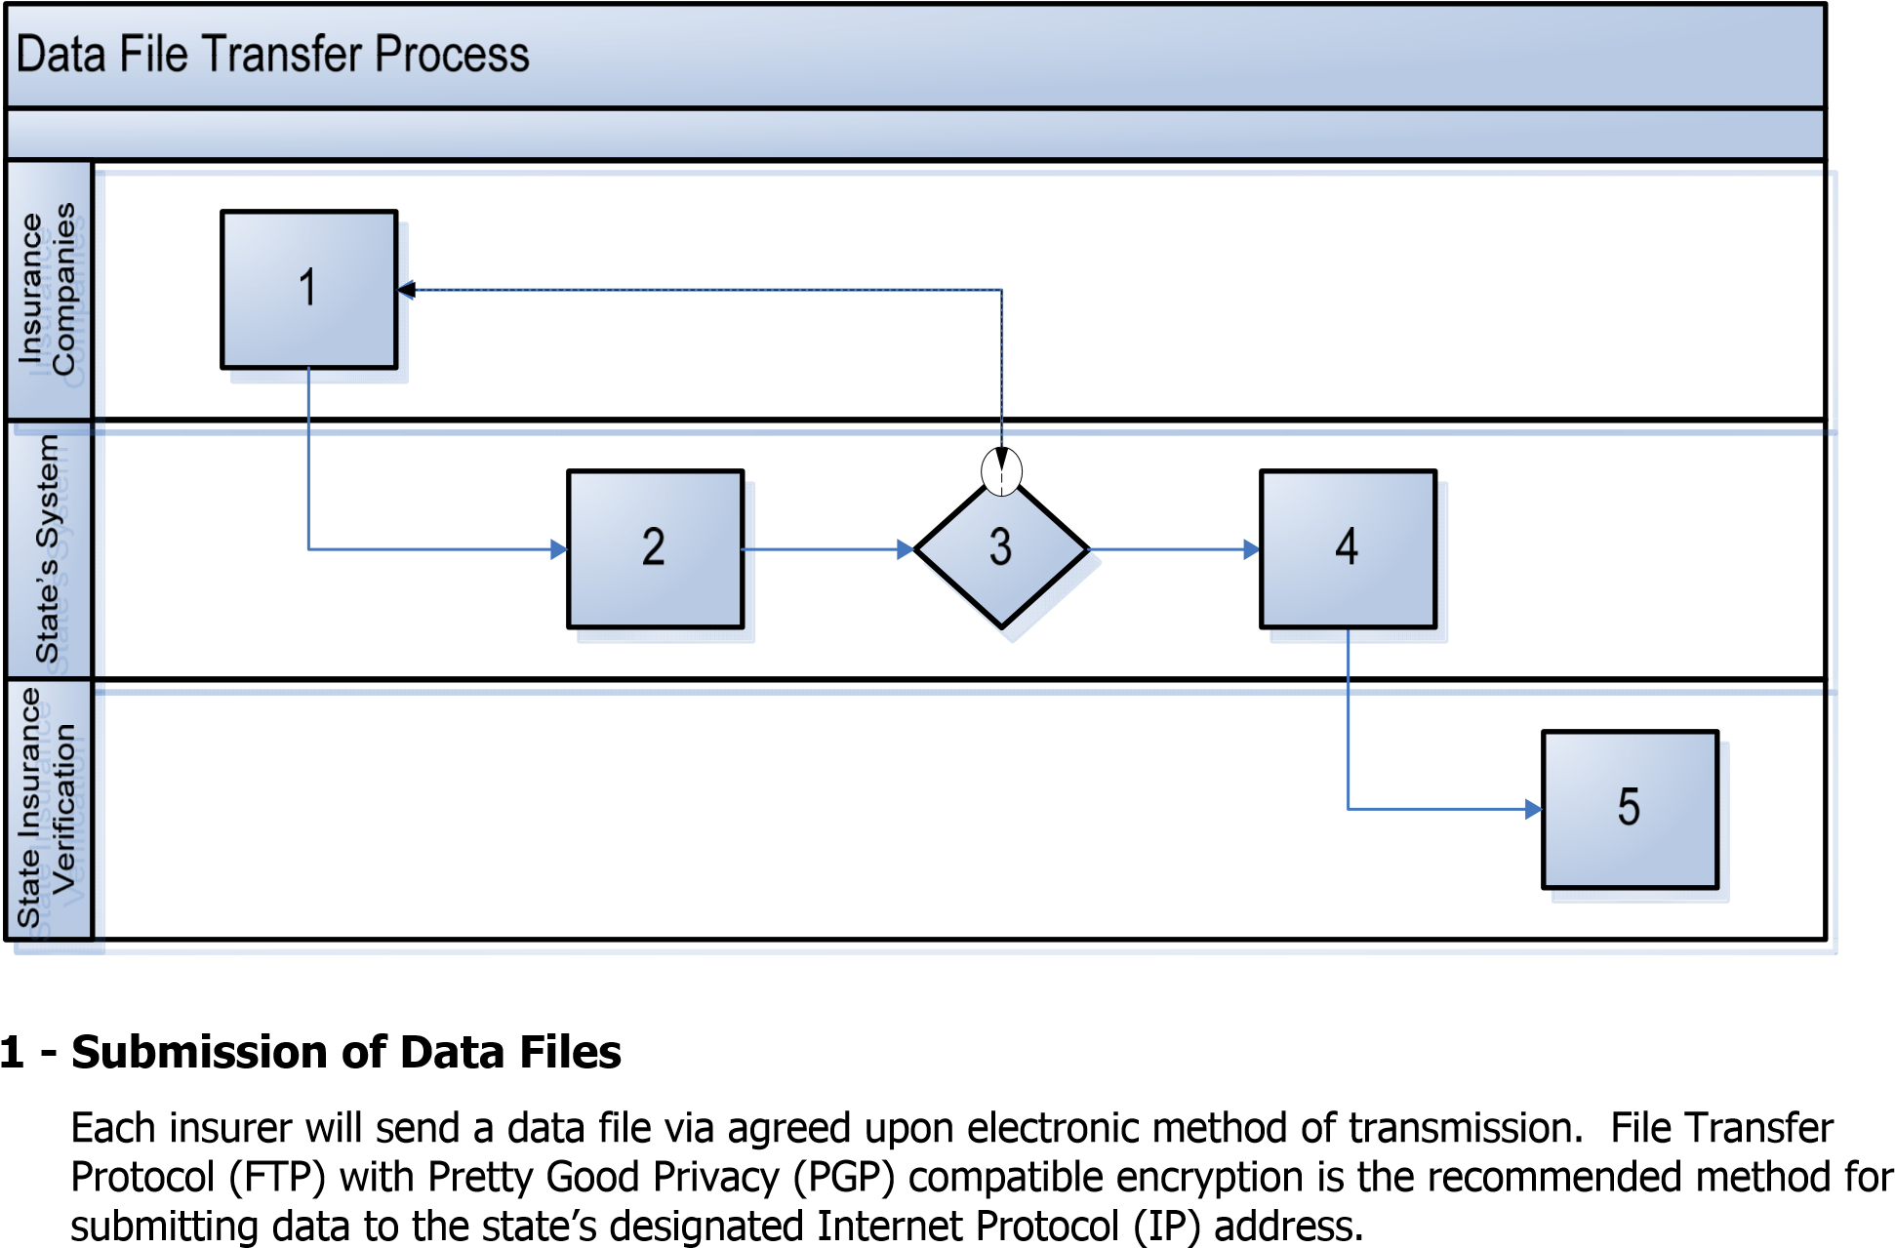

2- State’s System – Receipt of Insurance Data Files
The state’s application will verify that each company has sent an insurance data file. If a file has not been received from a specific insurance company, the company’s designated contacts should be notified immediately via e-mail or other agreed upon electronic notification method.

3 - State’s System – File Format Validation
Upon receiving data files, the state or its designated vendor will validate the file format to ensure that it adheres to the standard as outlined in this document.
Files that fail to meet the set standard will be rejected by the state’s system. The rejection can be conveyed in the form of an e-mail or automated electronic notification to the respective company’s designated contact. An option for insurance companies to receive a notification of the file’s acceptance will also be available. The impacted insurance company will then have an opportunity to correct and resubmit the data files.

4 - State’s System – File Process
The state’s system will incorporate a process to identify the current insurer of record.
Note: The return of individual records to the submitting insurance company for further processing is not within the scope of this process.

5 - State Jurisdiction – Insurance Verification Process
The state, upon receiving notification of vehicles from the file processing system, has the option to request proof of insurance coverage directly from the registrants of those vehicles. If the state so chooses, the information provided by the vehicle registrants can be used to verify coverage directly with the insurance company by using the IICMVA Online Insurance Verification Model web service.

Data File Format
The data in each record shall always be recorded in fixed length fields using the 7-bit American Standard Code for Information Interchange (ASCII).
The field name “Mandatory/Optional” is used to identify data which is required (Mandatory) or optionally (Optional) provided by the entity transmitting the file. “Optional” data fields will be transmitted at the discretion of the insurance company based upon the submitting company’s independent business rules.
Transmission methods and security processes allow for the identification of sender and receiver of data which eliminates the need for a header record. The trailer record was included to allow the receiver to validate all data sent was received.
Each record shall consist of a record size of 300 bytes and adhere to the following structures:

Detail Record

Field Name | Length | Begin | End | Type | Mandatory /Optional | Description
POLICY TYPE | 2 | 1 | 2 | AN | M | ‘VS’ = Vehicle Specific  ‘NS’ = Non Vehicle Specific
NAIC | 5 | 3 | 7 | N | M | NAIC Code
POLICY NUMBER | 30 | 8 | 37 | AN | M | Policy Number
EFFECTIVE DATE | 8 | 38 | 45 | N | M | Effective Date – YYYYMMDD format
VIN | 25 | 46 | 70 | AN | O | VIN  (optional for non-vehicle specific policy)
LAST NAME or ORGANIZATION | 40 | 71 | 110 | AN | O
PREFIX NAME ABBR | 3 | 111 | 113 | AN | O
MIDDLE NAME | 20 | 114 | 133 | AN | O
FIRST NAME | 40 | 134 | 173 | AN | O
SUFFIX NAME | 3 | 174 | 176 | AN | O | Abbreviated Name Suffix (JR, SR, etc)
FEIN | 9 | 177 | 185 | AN | O
ADDRESS | 50 | 186 | 235 | AN | O
CITY | 35 | 236 | 270 | AN | O
STATE | 2 | 271 | 272 | AN | O
ZIP | 5 | 273 | 277 | N | O
COMMERCIAL POLICY INDICATOR | 1 | 278 | 278 | AN | O | Y for Commercial Policy
FILLER | 23 | 278 | 300 | AN | M | Space Filled

Trailer Record

Field Name | Length | Begin | End | Type | Mandatory /Optional | Description
TYPE | 2 | 1 | 2 | AN | M | ‘TR’ = Trailer
RECORD COUNT | 12 | 3 | 14 | N | M | Record count not including Trailer Record
PROCESS DATE | 8 | 15 | 22 | N | M | Date the file was created – YYYYMMDD Format
FILLER | 278 | 23 | 300 | AN | M | Space Filled

Insurance Industry Committee on Motor Vehicle Administration

